

**SEMITONE**

The smallest interval between two notes.

(2 keys directly next to each other on the keyboard are a semitone apart)

**TONE**

Two semitones next to each other.

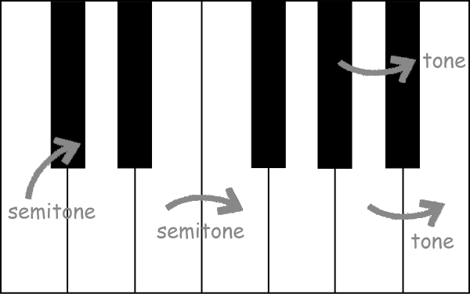

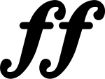

fortissimo – very loud

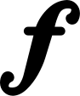

forte - loud



mezzo-forte – medium loud



mezzo-piano – medium quiet



piano - quiet



pianissimo – very quiet

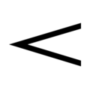

crescendo - getting louder

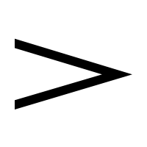

diminuendo - getting quieter

Violin-viola-cello-double bass

Flute-oboe-clarinet-bassoon

Trumpet-trombone-french horn - tuba

Timpani –cymbals

Piano

Harp

Saxophone

Guitar – electric & acoustic

Drum kit

Ensemble

Major

Minor

Chord

Primary & secondary triads

Diminished chord

Seventh chords

| Note | Name | Rest on the Stave | Beats |
| --- | --- | --- | --- |
|  | Semibreve |  | 4 |
|  | Minim |  | 2 |
|  | Crotchet |  | 1 |
|  | Quaver |  | ½ |

Loud & quiet

Crescendo

Decrescendo

Question & answer

Introduction

Coda

Link

ABA

Verse

Chorus

Bridge

12 bar blues

Thick & thin

Unison

Solo

1, 2, 3 part

Round

Layers

Melody-Chords-Bass

High & Low

Step & Leap

Tone & Semitone

Rising & Falling

Tonic

Motif

Sequence

Treble Clef

Pulse

Rhythm

Semi-breves, minims, crotchets, quavers.

Ostinato

BPM

Syncopation

4/4

3/4

Fast & Slow

Accelerando

Ralentando

**The Elements of Music**

Pitch and Rhythm, Metre, Tonality and Texture Structure Dynamics Instrumentation/

Melody tempo Harmony Timbre

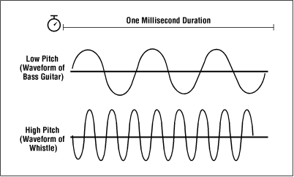 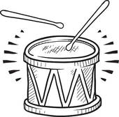 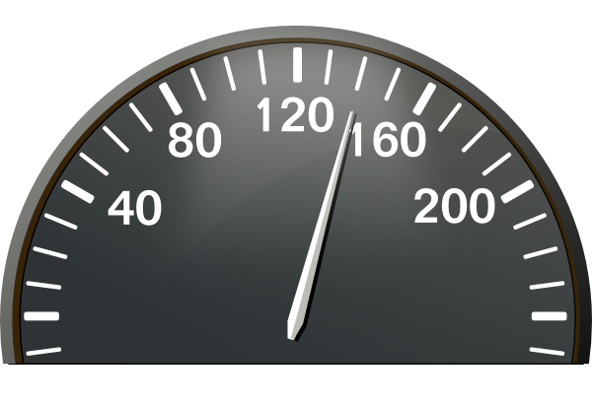  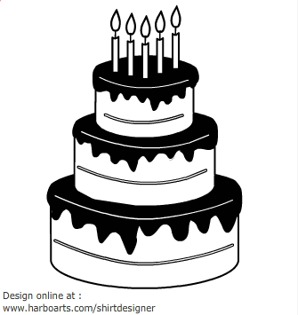 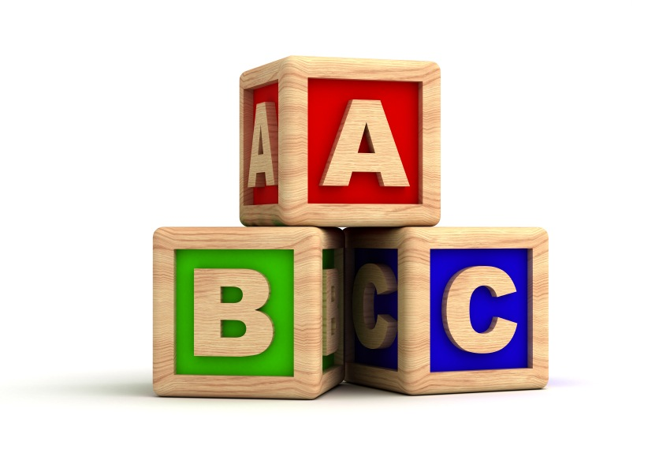 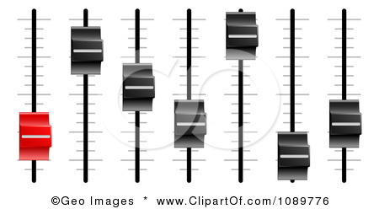

top number:

**how many beats**

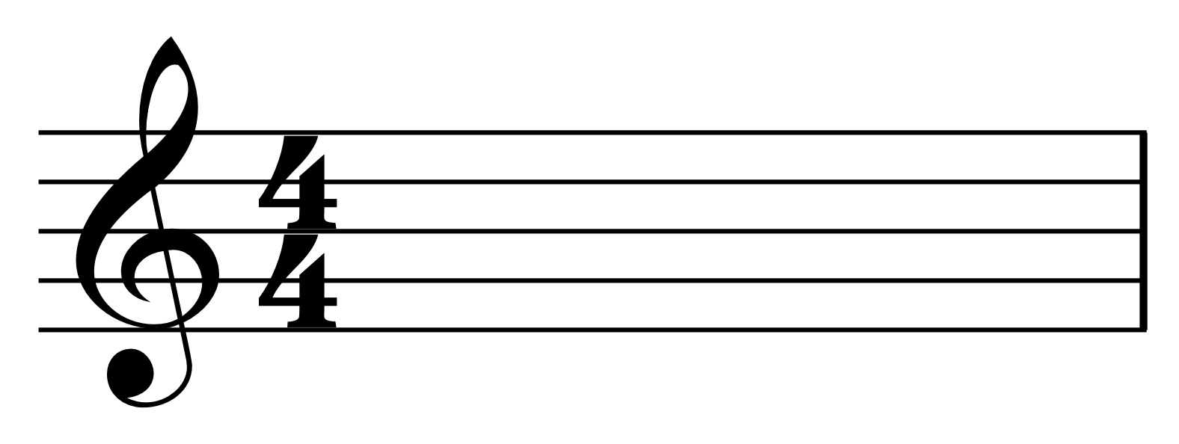

bottom number:

**type of beat**