Mozart Piano Sonata K333
Piano: Alex Tchernakova

Timings | Content and notes
5 mins | Introductions and context of set work  SLIDE ONE
1784 publication - 13th piano sonata of 18
Written for the fortepiano and to be played by domestic players
- Fortepiano (loud-quiet)
- Delicate and subtle it enabled the player to control the weighting of the fingers and balance the melody and accompaniment
- Even quavers could be light and fluid in lh while ornaments could be beautifully weighted in the rh
- Narrow range for confined pitch range; much of lh is in treble clef

8 mins | Performance of first movement (without repeats) *
 | Thank you
8 mins | The Context  SLIDE TWO
Typical of the classical period a ‘style galant’ Elegance - Form - Symmetry
Exam question possibility (10 marks)
- Use of fortepiano
- Melody dominated homophony
- Broken chord accompaniment at start *
- Alberti bass bar 71 *
- Pick a bar of Alberti bass you’d like to hear
- Clear harmonic progressions with regular cadences
- SLIDE THREE
- * play bars 1-4 in
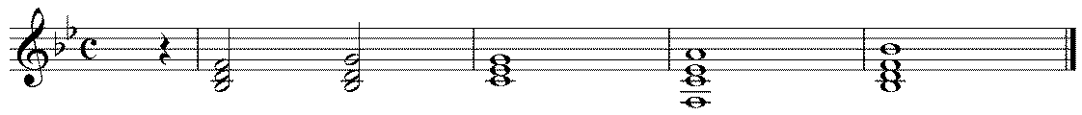reduction then as original
I VIb II V7 (dom 7) I

- Functional chords and keys (related)
- Cadential 64 (Ic-V-I) in 57-59 *
- Periodic phrasing, note opening is 4 bars then six!

2 mins | Sonata Form and the subjects  SLIDE FOUR
Mozart uses this to control his sections and provide perfect balance and symmetry. Brief S Form overview. Harmonically functional.

- Exposition
First and Second subject in related keys (Bb then F - functional) *
SLIDE FIVE
First subject
- Starting appoggiatura
- Elegant with broken chords in lh and scalic movement in rh * bars 1-8

Fingerprints of second subject
- Announces arrival with a grand chord in F
- Syncopated
* second sub

10 mins | The core melodies
Sonata form allows Mozart to explore a range of melodic ideas, unlike some monothematic compositions of Haydn.
This profusion of melodies is important and melody is the driving force behind this work

- Characterised by the distinctive conjunct scales * 6-10
- Sequences (extend melodies) *bars 27-28
- Appoggiaturas and APNs.
- Diatonic with a little chromaticism for colour * 39-50
- Trills, ornamental in character
- Stability provided by functional harmony: Circle of fifths *47-48
- Pedal notes * 57-59

5 mins | Development Section  SLIDE SIX AND SEVEN
Use of chords and development of motifs from subjects. Immediately you hear the first subject extended with a sequence *

3 quavers at end of bar 1 are developed in bars 66, 67, and 69 *
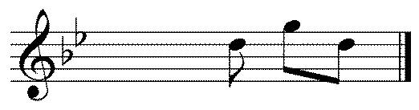
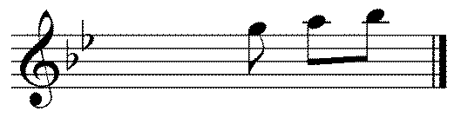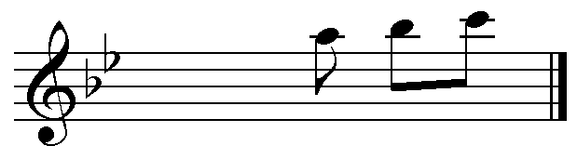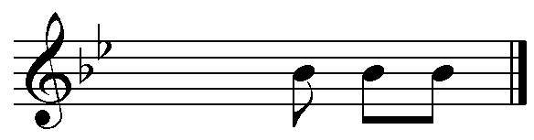

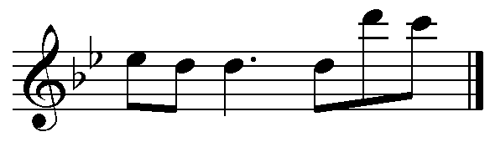 intervallic aug bar 79

Another set of examples if time (on slide seven)

After a perfect cadence in bar 70 there is a dramatic move to F minor (dom minor)
Then an exciting move through C minor and Eb minor (dark)

Bar 87 focus around F dom 7th as a dominant pedal for return to Bb

5 mins | Recapitulation
Second subject returns in the tonic key to add a sense of overall balance and symmetry *
Circle of Fifths from bar 47-48 * extended bar 143-146 *
Long pedal note bar 159
Then after a little chromatic colour and an d an elegant turn it finshes with a perfect cadence
20 mins | Performance of the piano sonata
Thank yous
SLIDE EIGHT

